**4Engineering Seminar Report**

12/2/21

Thermal Laser

Michel Lemay

Robert Bara, Zari Grandy-Overton, Ezra Galapo, Tyiana Simon

# Background & Significance

Nociceptors are essential sensory neurons that allow organisms to be alerted of potentially damaging stimuli (pain) when exposed to extreme changes in temperature, pressure, and injury-related chemicals to their skin. Nociception is a survival skill for all living organisms, any damage caused to this neurological system could put any creature or person in a potential life-threatening situation, if the neurological reaction is unrecognized (Dublin and Patapoutian, (2010), p.1-3). Spinal cord injury and associated treatments lead to modifications in the sensation of pain, and those changes are monitored with a number of assays that include the skin nociceptors’ reaction to heat. A common heat plantar test known as the Hargreaves Test, is a method of measuring thermal nociception by applying thermal stimulation to animal models of hyperalgesia and capturing the response time of paw withdrawal (Hargreaves, (1987), p.1). By creating a cost-efficient modified Hargreaves to collect data in organisms such as felines, further technological development to create a spinal cord injury model will promote sustainable development in good health and well-being, and life on land for felines and potentially other animal groups.

# Benchmarking

When designing a spinal cord injury model, different studies have been performed for testing nociceptors in a variety of mammals.

One way to quantify the behavioral responses of hyperalgesia is the Randall and Selitto method which uses mechanical force to generate nociceptive (the ability to feel pain and act accordingly) stimulus. Limitations to this test also include the inability to be automated, so it is relied upon by human observations while the animal is restrained. The force also must be quantifiable, which is hard to do with the animal being on the platform which is why there needs to be some sort of force sensor to help with this problem. The Hargreaves test designed in 1987 aimed to improve this test by using radiant heat on an unrestrained animal and synchronously utilizing an automated system to determine the nociceptive range (Hargreaves, (1987), p.1).

Different tests that occurred to test the Hargreaves hypothesis were to put rats into a room where they can become acclimated to the environment. Due to the Ethical guide of animal cruelty, the rats are to be tested once only on every time point. 8 rats were held onto the floor to expose the rats to the radiant heat that was applied to the glass. One paw would receive “a subcutaneous injection of 1.0 mg CARRA in 0.1 ml saline, and the other paw was injected with the same volume of 0.9% saline (SAL).” Two hours passed after the injection the rats were tested. A microprocessor was able to record the precise time and temperature of the test after it was done. “The radiant heat was a high intensity projector lamp bulb located 40 mm below the glass floor and projecting through a 5 mm x 10 mm aperture in the top of a movable case. A photoelectric cell aimed at the aperture detected light reflected from the paw and turned off the lamp and the electronic clock when paw movement interrupted the reflected light.” By using a laser, it was able to determine when the rat would move once it broke the continuous stream of light (Hargreaves, (1987), p. 2-3).

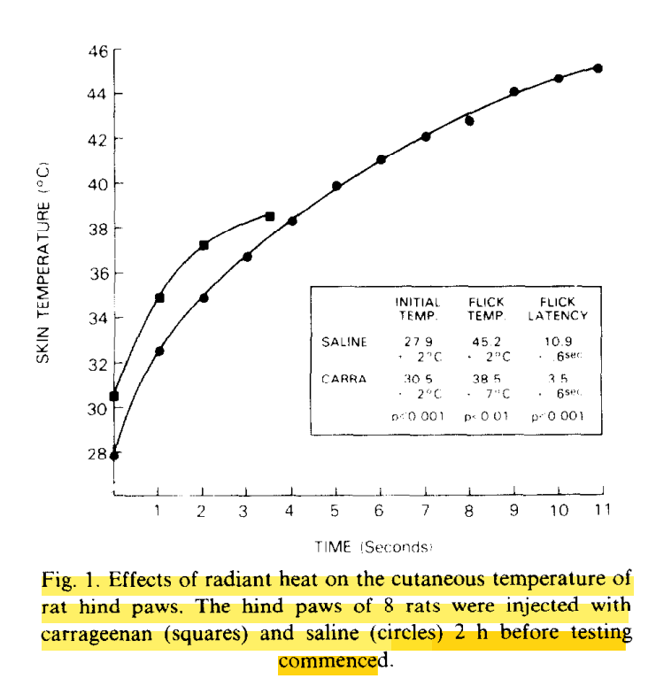

Since the initial 1987 Hargreaves study, the test has continued to be performed in a number of studies. The test is typically done on rodents to test their thermal pain sensation. Via rodents, the test analyzes the effectiveness of their somatosensory system, specifically focused on sensory stimuli. Pain, touch, pressure, and vibration are crucial factors that are studied to gather valuable information towards repairing this system if it falls victim to injury. Plenty of these tests are ran on rodents to make discoveries in relation to patients who suffer from neural injury, the goal is to observe whether there is an actual defect and if so, find suitable treatments towards neural regeneration (Cheah et al, (2017) pg.1).

One performance of this test has previously been done by a Europe PMC Funders Group in 2017 (Cheah et al, (2017) pg.2). This group’s test consisted of both mice and rats; with specific strains of the rodents recommended for the most effective results in data collection (i.e., one kind being more active than another which can affect the accuracy of the test). The setup consisted of a frame glass panel (glass table), a glass animal enclosure, an emitter/detector vessel, and a controller.

It was important that they inhabit the rodents into the testing chamber/ enclosure to ensure that they would remain calm and still during the test. They did this for two days for 30-60mins, allowing them to find comfort in the environment; they were also fed and taken care of in the process. The enclosure was constantly disinfected after each use to eliminate outlying factors during data collection. Therefore, when the test was administered, after giving the animals 15-20 minutes to settle in the enclosure, the emitter/detector was positioned directly under the center of their paws (one rat at a time, whichever paw being tested), and when fully set up, the “start” button on the controller was pushed. Pressing “start” turned on the infrared light and automatically started the timer. The test ended when the rodent reacted and removed its paw from the glass enclosure which then got detected by the vessel, the vessel detection turned off the infrared light and stopped the timer. The test is suggested to be repeated for at least three trials to observe the average reaction time, however the max recommended; if time allows, is five trials to eliminate the highest and lowest reaction time and collect a more accurate average. It was noted to beware of actual paw removal due to the heat of the infrared light (involuntarily by the animal), so they paid close attention to the animal as it was tested and saw whether it checked its paw or licked it following the reaction, otherwise the trial was thrown out to avoid voluntary movement and the possibility of faulty data. Their test was restricted to 20 seconds max testing time if the animal did not react before then. This was protocol for burn injury prevention. There was also a requirement of allowing at least five-minute intervals in between testing the same animal. The test ran by this group was straight-forward and allowed them to collect acceptable data amongst a variety of rodents (Cheah et al, (2017) pg.3-5)**.**

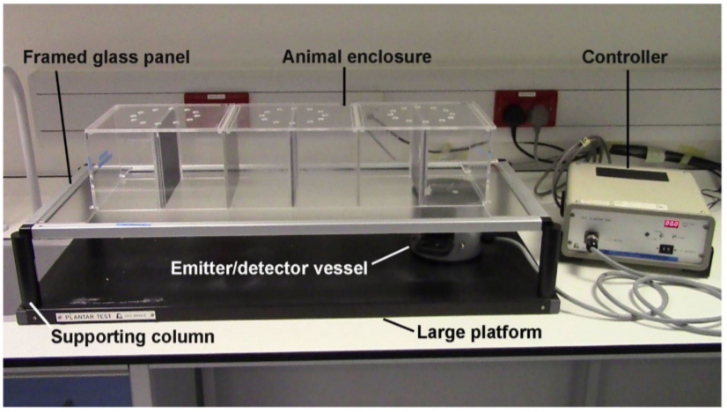

Figure 2. Hargreaves Test Apparatus

It is known how the Hargreaves works on rodents but a glimpse on how it works on humans and primates was needed to see if it can be safely used on humans. Normally there is quantitative assessment used to test the effect on non-crossing and crossing sensory pathways, but it does not give a good result. Quantitative assessment is not as good to use because it can often lead to inconsistent results, even the machines used to get the results have been known to be unreliable (Ma et al, 2015). Finding a way to measure the pain threshold but getting a correct response can be done using a modified Hargreaves. Performing the test, eight monkeys, primates, fifty-five healthy humans selected, and twelve humans with chronic sensory deficits were chosen. The test continued to stick to general Hargreaves procedure by measuring pain threshold through a plantar surface from heating up the footpad through a glass platform. Upon testing the Monkeys, they were restrained to a chair with their eyes covered by googles. This was done so that the monkeys could not remove their hind paw due to visual stimulation. The results from this test were the ability to realize that the Hargreaves test can be applied safely on larger mammals besides rodents, such as humans, and yield accurate responses.

Keeping the previous studies in mind, developing a prototype to test a spinal cord injury model for large animals such as felines could utilize various methods to trigger nociception. The Hargreaves test is typically done with a filament (i.e. the heat source is a plain lightbulb); however, a major disadvantage of heat generated by a filament is the limited ability to increase cutaneous temperature at a fast rate, which would not allow peripheral and central neuronal responses to be synchronous. Other behavioral nociceptive testing methods include electrical stimuli, which while easily controllable, bypasses the generator compartment of nerve terminals when applied to the peripheral nerve, and therefore loses information regarding the transduction process. Mechanical stimuli such as needles do not only activate nociceptors but activate mechanoreceptors. Additionally, the process takes longer to test compared to other methods. The benefit of using a thermal laser allows for a fast rate of changing cutaneous temperature while activating nociceptors within a few milliseconds (Plaghki and Mouraux, (2003), p.2-3). However, some drawbacks include the lack of a thermal laser system which automatically detects responses, unlike using methods such as utilizing an electric hot plate in conjugation with an automated system or mechanical methods involving flicking the tail of the animal (Hargreaves, (1987), p.1). However, if an automated system is developed, the decision to use an Infrared Laser diode for a modified Hargreaves plantar test would yield the most precise test data over methods such as electric, mechanical, or heat stimulation. Additionally, this project aims to create a cost-efficient model that will obtain data through a computerized system. The system ideally will automatically measure and log a valid response in paw withdrawal to be exported data for testing technological developments to aid in spinal cord injuries.

Previous research for this system has already been constructed at Temple University under Dr. Michel Lemay, upon which the following system has begun establishing a basic prototype. The power supply delivers power to the driver circuit which acts as a constant current source by sending a signal to drive the laser triggered by a program written in the Raspberry Pi (RPi). The constant current source is connected to the laser through the butterfly laser diode mount, which also connects the thermoelectric cooler (TEC), designed to prevent the laser’s temperature from overheating. The TEC is also powered by the power supply. The OFLD-1440-200s laser also utilizes a powerful heatsink, which so far has made the TEC act only as a backup cooling system. The photodiode circuit is also connected to the RPi and works by placing the test animal’s paw upon the photoresistor. When the laser heats up the animal’s paw, the animal removes the paw from the photoresistor, which increases the resistance due to more light being detected. This sends a signal back to the RPi to stop the laser. Additional block diagrams, pinouts, and schematics of the individual circuit components may be referred to within the appendix.

Figure 3. System Schematic of Laser System

# Functional Requirements and Design Constraints

The main Functional Requirements of the plantar animal model test will include the following. Creating a computerized system to interact with the current hardware (though the hardware may be modified) which will automatically turn on the laser/off the thermal laser based upon the animal’s paw being placed over the photodiode circuit. Furthermore, the withdrawal response time should be recorded and yield a response of less than or equal to +/-10 milliseconds to satisfy the client’s expectations. Ideally, the system should be user friendly, ideally with the development of a Graphical User Interface (GUI), or at the minimum, a shell script to trigger the necessary files to activate the system. Testing the overall hardware and software should be repeatable within the animal group and done humanly with little to no paw/tissue damage done to the test animal. If the team is successful in creating a functional prototype, the end goal is to obtain a patent, with the hopes of contributing to the United Nations Sustainable Development Goals by promoting a cost-efficient, stable system that can be easily manufactured (United Nations, *Goal 3 | Sustainable Development*). This would allow researchers to perform Plantar Tests using a more precise and cheaper method than a typical method such as the Hargreaves Test. Using data from our test could allow researchers to test their technological and neurological solutions on animals such as felines, and further develop advancements. This would align with the goals of promoting Good Health and Well-being in animals or potentially humans, since as Dr. Zhengwen Ma and Dr. Yao Li research concluded that nociceptive plantar testing is a valid method of testing spinal cord injury developments in primates and humans (Ma. et al. (2015), p.7). Additionally, the system would contribute to the goal of preserving life on land, since developments in correcting spinal cord injuries in animals, could be applied to helping domesticated animals (United Nations, *Goal 15 | Sustainable Development*).

In order to fulfill the functional requirements, some design constraints to be considered will be the following. The timeline of the project only grants the team two semesters to complete and validate the system. In order to combat this, the ergonomics of the team to promote maximum efficiency will include staying organized by utilizing Microsoft teams filesharing in conjunction with Edusource, along with task management through the use of the “Trello” application, which allows us to lay out a “to-do list” of tasks that need to be done, specify which tasks are currently being worked upon, and which tasks are completed. The aim of using this system is to allow us to break up larger tasks into smaller weekly tasks and divide the work up evenly amongst the team. This will also allow the project coordinator or other team members to examine what is currently being worked upon, and through the application’s comment/file sharing system, we can establish a checklist for each task and document where we are facing issues upon completing a task. This would allow other members or advisors to step in and collaborate on a solution or shed light to further constraints the team may not be aware of. Previous Senior Design teams have utilized a similar system to stay on track, and several research labs such as Dr. Bai and Dr. Thomson’s labs have utilized this system. From Robert Bara’s experience working in their lab for a year and a half, the workflow has been positive and efficient, which is why we are aiming to apply a similar workflow here. Ultimately, the bulk of the project’s problem-solving and conflict-management skills will probably stem from using this work ethic.

Design constraints to the actual system primarily include the following ethical considerations. To develop a system to safely be used on felines, the system must consider animal welfare for performing the test, as well as safety protocols for the team when developing and testing the apparatus. The Animal Welfare Act (AWA) is the federal law in the US that provides guidelines that regulates use of animals in research. The act gives a set of standards regarding housing, handling, sanitation, food, water, veterinary care and protection from weather extremes. The act over the years has been amended a few times to give more protection to animals and greater fines to those who do not follow the amendment. Even though each of the changes are important, the key one that this senior design should focus on is the Improved Standards for Laboratory Animals (ISLAA). In December 1985, the Food Security Act (P.L.99-198) was added to AWA, which includes ISLAA. The amendment was created to help with minimizing the pain and distress of animals that are in a laboratory environment. If there is a researched facility, there must be a veterinarian and an unaffiliated person that has to represent the welfare of the animals. If the regulations set forth by AWA are not followed there would be violations up to $2,500 (*Animal Welfare Act).* Prior research mentions the Hargreaves test upholding the International Association for the Study of Pain (IASP)guidelines. IASP guidelines for the use of animals in research supports the use of animal testing for the “development of new approaches for the management of pain.” It is understood that the range of testing can be on the spectrum of analyses that observe acute pain as well as the extreme of more complex testing that cause the nervous system to be altered because of tissue injury. With these conditions it’s always expected that those who perform experiments on live animals are doing so humanely. The IASP endorses the animal welfare policies and guidelines that are established by many national and regional organizations. The reference in this case would be U.S based policies and guidelines and researchers are expected to abide by them. All publications of work after research findings must be verified by authors in compliance with these guidelines upon submission (IASP, *Guidelines for the Use of Animals in Research*, (2021), p.1). There are no local references or recommendations for our specific location of research, therefore the Animal welfare act will be the primary point of reference for our project, but we will keep other references in mind to develop the most humane system. Before any animal testing occurs, the following safety procedures will be performed.There must be proper signage around the machine to make sure that people are aware of testing. A quick way to turn off the laser in case of an emergency will be developed. Before starting tests, a preliminary test at a lower energy level must be done. While assembling the laser it should avoid eye level whether the person is standing or sitting, we must make sure the area is clear around the table, and there cannot be any reflective material near the laser. Personal Protective Equipment (PPE) should be labeled and stored in front of the lab. There needs to be a pair of proper safety glasses for everyone near the laser with the correct optical density and wavelength. Only use material that will not produce harmful chemicals when the laser is applied to it, and the laser should be covered while not in use or once it is finished. (*Laser Safety Manual*). Ultimately, any testing with the laser will be performed by ourselves, if it is unsafe for humans, then it is unsafe for animals, and even if it is safe for animals, we will still obey the animal welfare act to ensure that animal testing is done as humanely as possible.

Additionally, the project aims to create a cheaper system than the Hargreaves Test, meaning the finalized product must be less than $15k, and our contributions to the existing prototype must be within budget of $1000 granted to the four-person senior design team. Depending on our approach to designing the computerized system, we may need to upgrade components such as the microcontroller which is currently done using a Raspberry Pi. Furthermore, initial testing done by Dr. Lemay found that the photodiode component has been too powerful in testing, yielding too many extraneous results, so the diode will most likely be replaced to ensure precise, accurate data collection for valid paw withdrawals. Any upgrades to these components may result in additional hardware upgrades/downgrades to overall circuit, which may impact the budget of the project, as well accessibility. Ideally, the final project design should be a non-engineer user-friendly, packaged-portable system with secure wiring and a testing apparatus that interacts nicely with the animals, so they are not uncomfortable or afraid of testing.

A summary of the current Functional Requirements and Design Constraints are displayed by the following tables.

Table 1: Functional Requirements with associated metrics, target values, and references*

|  |  |  |  |  |
| --- | --- | --- | --- | --- |
| **Priority**  **(negotiable or non-negotiable?** | **Functional Requirement** | **Metric** | **Target Value, Range, or Pass/Fail** | **Justification** |
| Non-negotiable | Ability to capture paw withdrawal reflex data, to be used as a basis of a spinal cord injury model for Felines | Computerized System implemented using microcontroller | Pass/Fail | United Nations Sustainable Development Goals: Good Health and Well Being, Life on Land/Client |
| Non-negotiable | No Paw burn/tissue damage to the animal | Power of laser/Heat Transfer to skin | Pass/Fail | Animal Welfare Act |
| Non-negotiable | Repeatability within an Animal group | Multiple trials and accessible to animals | Similar data within multiple trials for multiple test animals | Client |
| Negotiable | Withdrawal time | Test subject/counter | Min: ≤ +/-10milliseconds  Max: Less than a millisecond response time | Client |
| Negotiable | User Friendly interface | GUI/Hardware | Min: Shell Scripts for data collection and packaged system with stable wiring  Max: Full GUI interfacing, eliminating unnecessary hardware of current system, potential PCB design to eliminate offboard wiring | Future Teams, Prototyping, Patenting, etc. |

Table 2: Design Constraints with associated metrics, target values, and references*

|  |  |  |  |  |
| --- | --- | --- | --- | --- |
| **Priority (negotiable or non-negotiable?)** | **Design Constraint** | **Metric** | **Target Value, Range, or Pass/Fail** | **Justification** |
| Non-Negotiable | Time between animal testing trials/Minimum number of trials performed per day. | Heat to Footpad/Tissue Recovery | Min: > 3 trials  Max: ≤ 5 Trials  (Time between each trial will be calculated based upon hardware) | Animal Welfare act/Laser safety requirements for a  Class 3B laser |
| Non-Negotiable | Budget/Cost efficiency. | Cost | < $15k (More cost efficient than Hargreaves system) | Client/SD |
| Non-Negotiable | Animal Welfare | Animal’s interaction with System/Animal Health | No harm is done to animals. | Animal Welfare act |
| Non-Negotiable | Precise data collection-time resolution, and ability to validate the data. | Response time to laser | Min: Collect data at a rate of milliseconds  Max: Collect data at a more precise rate and validate this data | Client |
| Negotiable | Photodiode replacement | Interaction with 5V RPI | Min: Continue using the same photodiode  Max: Replace with better suited photodiode | Performance of system |
| Negotiable | Microcontroller replacement | Cost and Efficiency | Min: Continue using the RPI  Max: Use a smaller/cheaper microcontroller or FPGA while retaining efficiency | Performance of system |

# Room to Grow

Collectively as a group, we feel we have room to grow in the following areas of knowledge:

* Theoretical knowledge: While the Hargreaves test has strengthened our understanding of nociception, we still have a lot of theoretical knowledge to gain, such as understanding the biophysics of reflexes to nociception, this will allow us to determine a valid/invalid paw response to our tests and allow us to determine how we can verify our design on a technical and ethical level.
* Data analysis: We are unsure of the technological approach to capturing data generated by the laser. Furthermore, any data captured must be verified. A solid method to determine data collection must be developed by strengthening the team’s system test planning skills.
* System integration: Understanding how to overall link our work with the previous work already completed to establish a stable system. We understand some of the parts of the system and why they need to be created, but aspects of the system could be upgraded or removed for simplicity to create an efficient user-friendly system. Furthermore, examining the previous programming work and establishing any redesigns or further programming will be the bulk of our design, and establishing a workflow as a team to divide up the analog/digital work is what will excel the project.

# References

Cheah, M., Fawcett, J., & Andrews, M. (2017). Assessment of thermal pain sensation in rats and mice using the Hargreaves test. *BIO-PROTOCOL*, *7*(16). https://doi.org/10.21769/bioprotoc.2506

Dubin, A. E., & Patapoutian, A. (2010). Nociceptors: the sensors of the pain pathway. The Journal of clinical investigation, 120(11), 3760–3772. https://www.ncbi.nlm.nih.gov/pmc/articles/PMC2964977/

Hargreaves, K.M., Dubner, R., Brown, F.J., Flores, C., & Joris, J.L. (1988). A new and sensitive method for measuring thermal nociception in cutaneous hyperalgesia. Pain, 32, 77-88.

*IASP guidelines for the use of animals in research*. International Association for the Study of Pain (IASP). (2021, August 18). Retrieved November 26, 2021, from https://www.iasp-pain.org/resources/guidelines/iasp-guidelines-for-the-use-of-animals-in-research/

Hargreaves K, Dubner R, Brown F, Flores C, Joris J. A new and sensitive method for measuring thermal nociception in cutaneous hyperalgesia. Pain. 1988 Jan;32(1):77-88. doi: 10.1016/0304-3959(88)90026-7. PMID: 3340425.

*Laser Safety Manual - GVSU.EDU*. https://www.gvsu.edu/cms4/asset/C1D68F53-9CBF-F624-0510A5E74B1E19D7/laser_safety_plan_jan_2021.pdf

Ma, Z., Li, Y., Zhang, Y., Shields, L., Xie, Q., Yan, G., Lui, W., Chen, G., Zhang, Y., Brommer, B., Xu, X., Lu, Y., Chen, X., Shields, C. (2015). Thermal nociception using a modified Hargreaves method in primates and humans. *Funct Nuerol.* 30(4). 229-236. https://www.ncbi.nlm.nih.gov/pmc/articles/PMC4758775/

*Pasco Capstone™ Software*. PASCO scientific. (n.d.). Retrieved November 29, 2021, from https://www.pasco.com/products/software/capstone

Plaghki, L., & Mouraux, A. (2003). How do we selectively activate skin nociceptors with a high power infrared laser? Physiology and biophysics of laser stimulation. *Neurophysiologie clinique = Clinical neurophysiology*, *33*(6), 269–277. https://pubmed.ncbi.nlm.nih.gov/14678841/

United Nations. (n.d.). *The 17 goals |* *Sustainable Development.* United Nations. Retrieved November 27, 2021, from https://sdgs.un.org/goals

United States Department of Agriculture. (n.d.). *Animal Welfare Act*. NAL. Retrieved November 29, 2021, from https://www.nal.usda.gov/legacy/awic/animal-welfare-act

# Appendix: Project Description and Potential Solutions

Project Description: Design a computerized laser diode system that can measure the withdrawal time to a heat stimulus applied to the plantar surface of the foot in a large animal model of spinal cord injury. The system must provide automatic measurement of the paw withdrawal latency time and energy and store those values for later export.

Potential Solutions: Regarding potential solutions to the problem, we have to settle on a solid circuit for recording and exporting information which will be discussed below. Based upon the desired route the team decides, we could develop a physical apparatus to safely perform the test as well as package the system into a portable-accessible enclosure.

1. Continuing with the already developed system, we could develop an interface to check for the signal coming from the photodiode and upon starting the program it would project the laser into the animal’s paw whilst starting a counter to measure time. We could create a sort of digital filter to be implemented on the resistance delivered by the photodiode. This can be done similarly to labs we have performed within ECE 3623 Embedded Systems by using an ADC and set a limit to stop the laser and data recording when the limit is reached through a conditional. Additional sensors could be connected to the RPi for measuring changes in temperature or weight, in which we could develop another program to calculate changes in energy when the laser and recording is stopped. From this, each output can be saved and stored to a file located onto the RPi, and we could also investigate other ways of validating our system, such as using a small camera mounted in front of the of the photodiode, to visually determine a valid reflex versus the cat simply moving around. Together, we could integrate all the information using a ROS node, and potentially output the data to a local website that would utilize a user-friendly GUI programmed through a language such as JavaScript or Python.
2. One possible solution is to integrate an FPGA board to control the system instead of a microcontroller. We could do this by using a hardware language such as Verilog to build a D-flip flop like circuit which would take the photodiode’s state as an input enable signal. This would allow us to start a clock at a precise rate and start the laser circuit when the cat covers the photodiode, upon which the laser starts with the positive clock cycle. If we sample the clock rate at a small enough clock cycle, the cat will remove their paw and immediately at the next clock cycle the laser would stop running. We could then create another module to output the sum of the clock cycles when the laser was running, as well as convert the sum into seconds. Additionally, recording energy can be done through additional sensors, such as a force sensor, scale to measure the weight delivered onto the photodiode, or the temperature changes using the TEC from the laser. Together these additional sensors could also be mapped to a microcontroller with a custom Verilog module. The benefit of using something like an FPGA is that everything would be done explicitly through hardware, and by using an FPGA board or by fabricating a chip to complete the circuit, we could simply utilize analog components such as buttons or switches to turn on/off the system, for user-friendliness.
3. Another possible solution to creating the computerized diode system is to integrate existing interfaces for data collection such as the PASCO Capstone hardware/software that is used in Temple’s physics labs. The Capstone software already has a user-friendly functional GUI which would allow for data to be exported and stored using tables, generated graphs, and additional calculations using features such as the signal generator, oscilloscope, and FFT analysis (*Pasco Capstone™ Software*.). By modifying the system to be compatible with the Capstone hardware, we would be able to record data in real time for time when the photodiode is on/off, and we would be able to purchase additional force sensors to allow us to calculate changes in temperature/energy for the paw withdrawal. This method, however, may require us to purchase a valid Capstone license and the bulk of the programming would require us to edit the source code of the Capstone software or develop a conversion software to modify the existing compatible Capstone ports into using the sensors to obtain data into the software.

# Appendix: Schematics/Pinouts

# Schematics of the work done so far to the prototyped system are as follows:

The over systems flows, starting with the power supply, which delivers power to the driver circuit acting as a constant current source by sending a signal to drive the laser triggered by a program written in the Raspberry Pi (RPi). The constant current source is connected to the laser through the butterfly laser diode mount, which also connects the thermoelectric cooler (TEC), designed to prevent the laser’s temperature from overheating. The TEC is also powered by the power supply. The OFLD-1440-200s laser also utilizes a powerful heatsink, which so far has made the TEC act only as a backup cooling system. The photodiode circuit is also connected to the RPi and works by placing the test animal’s paw upon the photoresistor. When the laser heats up the animal’s paw, the animal removes the paw from the photoresistor, which increases the resistance due to more light being detected. This sends a signal back to the RPi to stop the laser.

Figure 3. System Schematic of Laser System

A deeper in-depth schematic of the PhotoDiode circuit functions as follows, utilizing a voltage divider to set the bias of the PhotoDiode, with respective input and output signals.

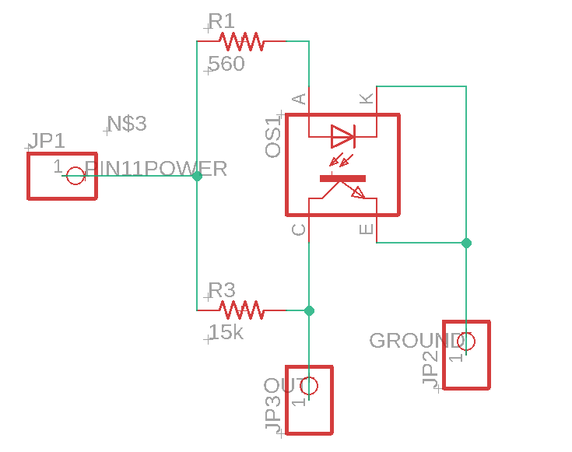

Figure 4. PhotoDiode Schematic

Technical details regarding the Butterfly Laser Diode mount include the following specifications and pinout diagrams.

Table 2. Specifications of Butterfly Laser Diode Mount

Table 3. Butterfly Laser Diode Mount Pin Diagram

Table 4. Butterfly Laser Diode Mount Pinout

A breakdown of the TEC circuit is as follows and can be referenced when connecting to the rest of the system.

Figure 5. Connecting the TEC to the Circuit